RÉPUBLIQUE DU CAMEROUN |  | REPUBLIC OF CAMEROON
Paix-Travail-Patrie |  | Peace-Work-Fatherland
**************** |  | ****************
MINISTÈRE DES ENSEIGNEMENTS SECONDAIRES |  | MINISTRY OF SECONDARY EDUCATION
**************** |  | ****************
DELEGATION REGIONALE DU  NORD OUEST |  | REGIONAL DELEGATION  NORTH WEST
DELEGATION DEPARTMENTAL DIVISIONAL ELEGATION
DE MENCHUM MENCHUM
**************** |  | ****************
Ref. N^{O} __220_/_20_/MINESEC/RDSE/NW/DDSE/MENCHUM WUM THE____11/08/2020______

FROM ;
THE DIVISIONAL DELEGATION
SECONDARY EDUCATION
MENCHUM DIVISION
TO :
THE HONOURABLE MINISTER
SECONDARY EDUCATION
THROUGH:
THE REGIONAL DELEGATE
SECONDARY EDUCATION
NORTH WEST
SUBJECT : INTERVIEW RESULTS FOR ADMISSION INTO FORM ONE IN PUBLIC COLLEGES OF
MENCHUM DIVISION FOR THE 2020/2021 SCHOOL YEAR

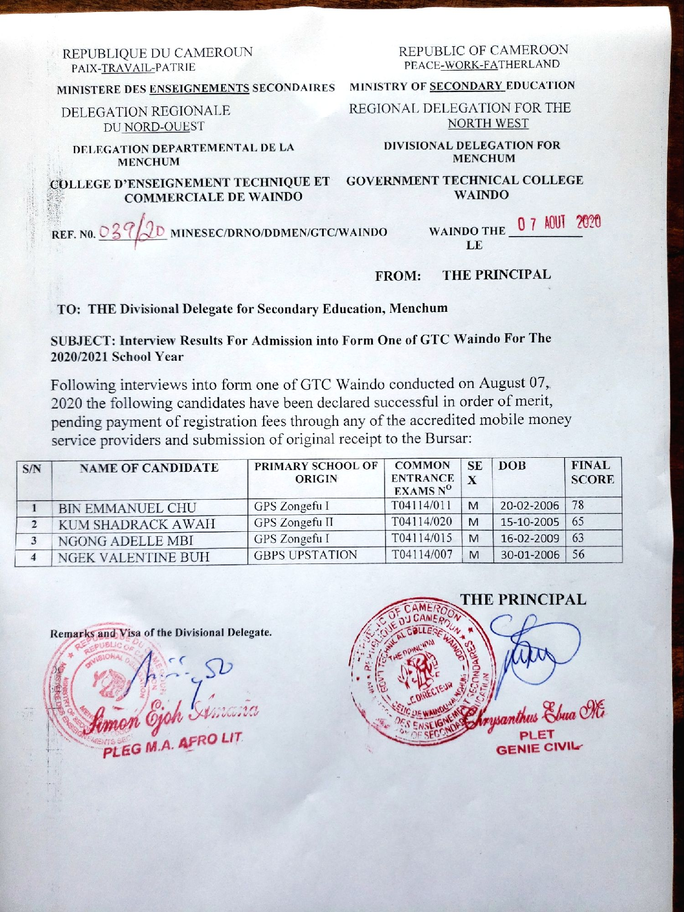
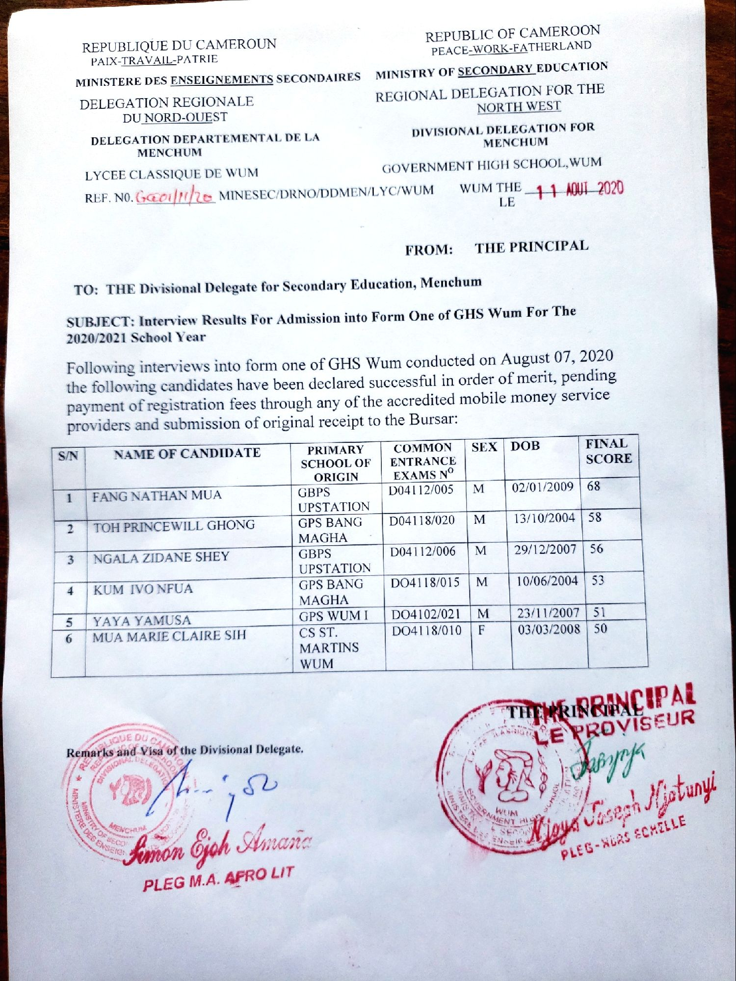

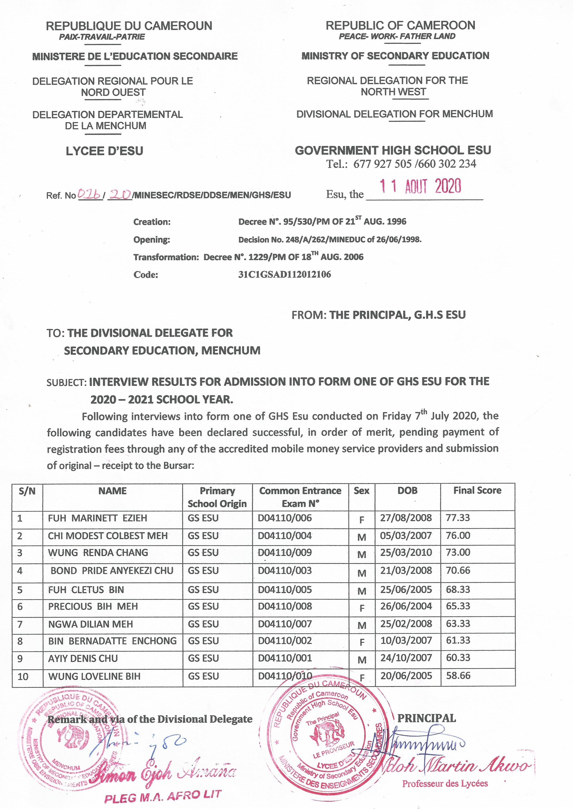
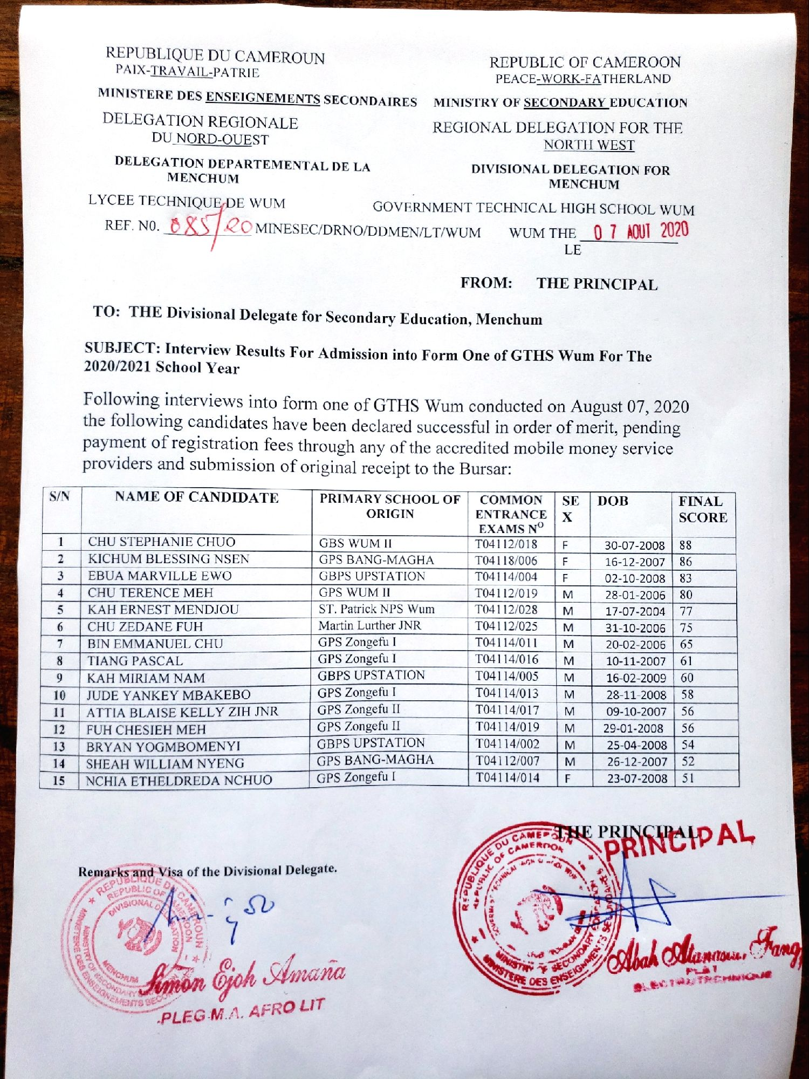

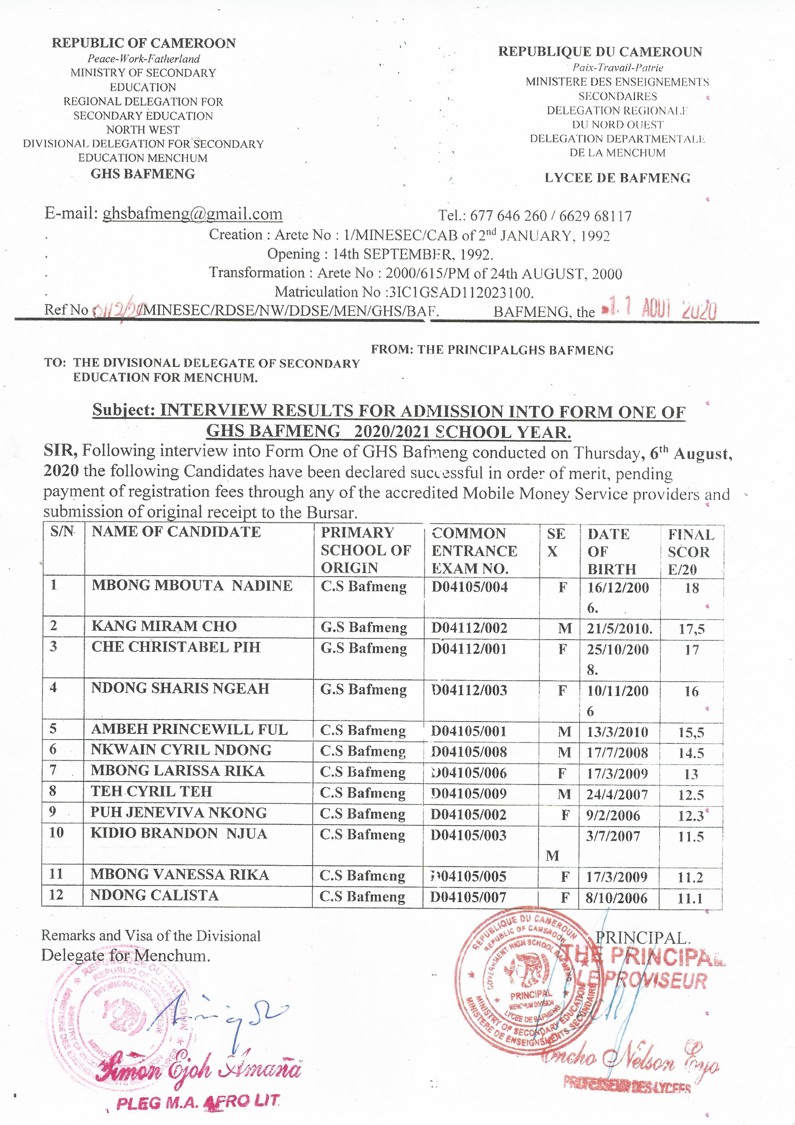

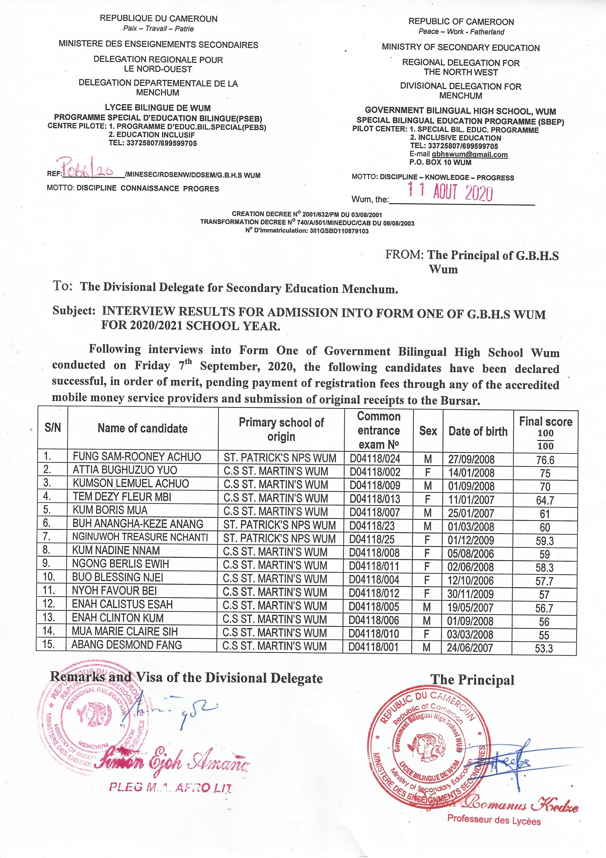
DEEPLY SORRY FOR THE DELAY DUE TO POWER FAILURE
THE DIVISIONAL DELEGATE
SIMON EJOH AMANA

